Scripting for server security on CentOS
AI Used : ChatGPT
Prompt used : Make a script for cybersecurity on CentOS
I had two script attempt.
The first one didn’t work out well. I had to make some modifications and make it simpler
However, I had to go through some settings issues.
I couldn’t past the script from Windows to Linux server.
I went to Virtual Box Advanced Settings to allow to paste
Screenshots of this process.

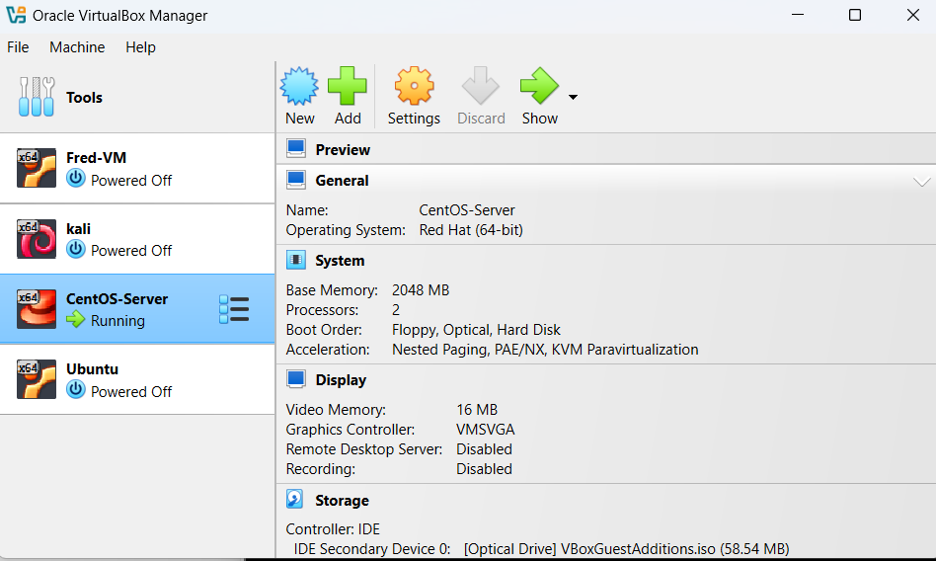

I choose Bidirectionnal for both shared Clipboard and Drag’n Drop
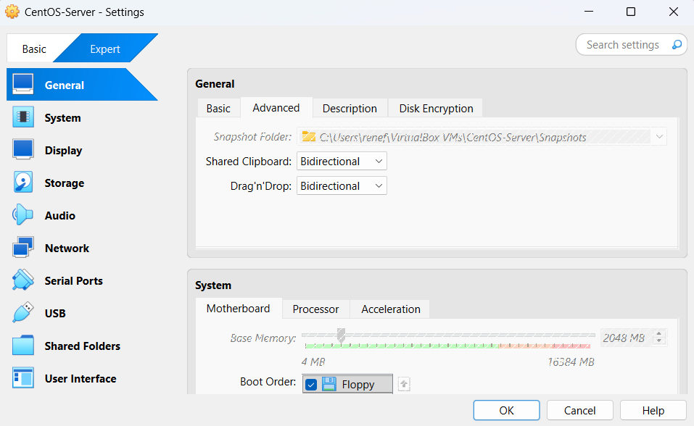

I had also to install kernel that took me a little time
Command use : sudo yum install -y gcc kernel-devel kernel-headers make
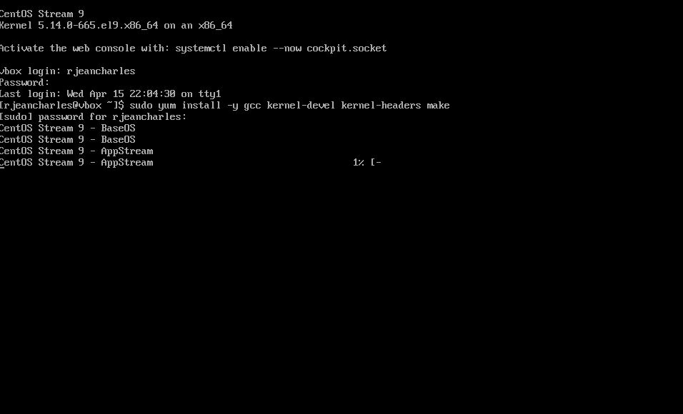

Sudo : Allows to install software that regular users cannot handle
Yum : allow to update or modify on centOS server
Install : Indicated that something need to be installed
-y : allow to do the installation process automatically without manual intervention
gcc: translate human readable source code into binary for computer to execute
kernel-devel : Provides kernel development files
kernel-headers :provider header files
make : it reads a file named Makefile allowing to automatically execute command that essential to build the program.

After this I was able to paste the script. There was still some limit, so I decided to type it directly
Command use : nano security.sh
nano : Text editor for linux command line
security.sh : name of file created that will hold the content

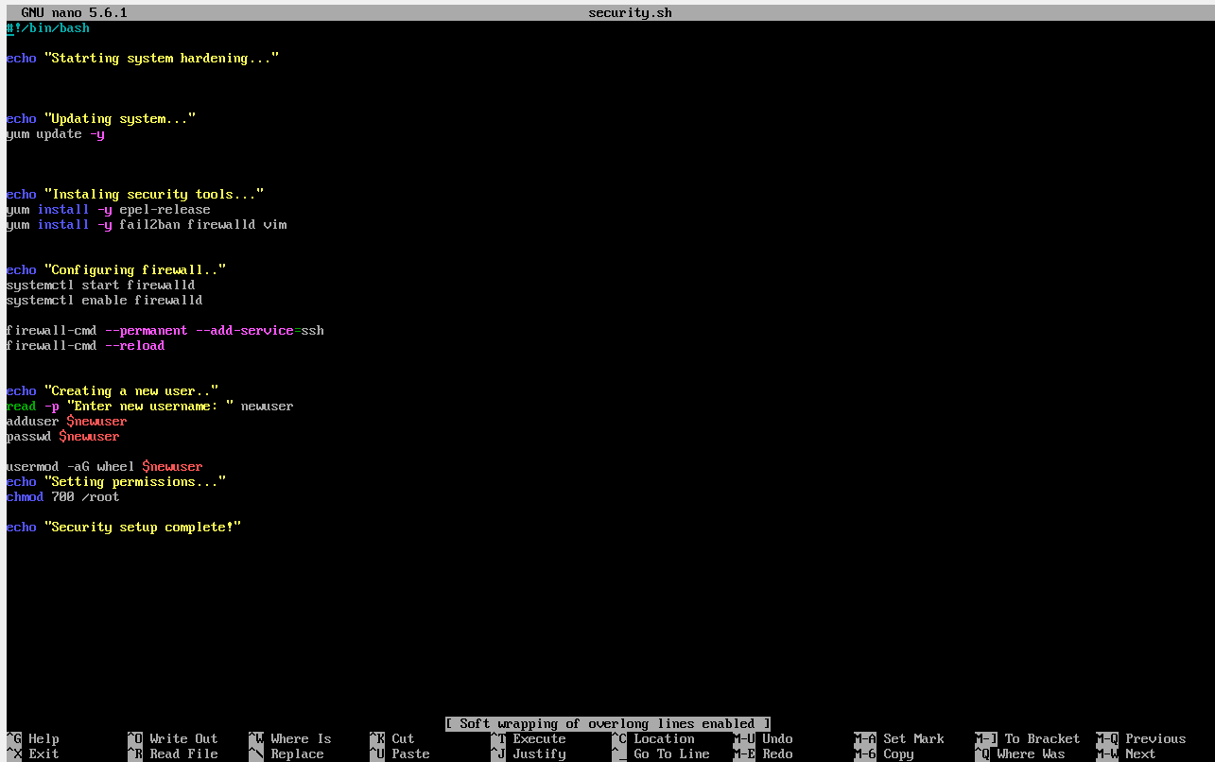

First script that causes problems that come from directly to AI.
# This is the ad explaining each line
#!/bin/bash
# ==========================
# Basic CentOS Security Script
# ==========================
echo "Starting system hardening..."
# 1. Update system
echo "Updating system..."
yum update -y
# 2. Install necessary tools
echo "Installing security tools..."
yum install -y epel-release
yum install -y fail2ban firewalld vim
# 3. Start and enable firewall
echo "Configuring firewall..."
systemctl start firewalld
systemctl enable firewalld
# Allow SSH (default port 22 for now)
firewall-cmd --permanent --add-service=ssh
firewall-cmd --reload
# 4. Create a new user
echo "Creating new user..."
read -p "Enter new username: " newuser
adduser $newuser
passwd $newuser
# Add to sudo group
usermod -aG wheel $newuser
# 5. Secure SSH
echo "Securing SSH..."
SSH_CONFIG="/etc/ssh/sshd_config"
# Backup config
cp $SSH_CONFIG ${SSH_CONFIG}.bak
# Change SSH port
sed -i 's/#Port 22/Port 2222/' $SSH_CONFIG
# Disable root login
sed -i 's/#PermitRootLogin yes/PermitRootLogin no/' $SSH_CONFIG
# Disable password authentication (optional - be careful!)
# sed -i 's/#PasswordAuthentication yes/PasswordAuthentication no/' $SSH_CONFIG
systemctl restart sshd
# Open new SSH port in firewall
firewall-cmd --permanent --add-port=2222/tcp
firewall-cmd --reload
# 6. Configure Fail2Ban
echo "Configuring Fail2Ban..."
systemctl start fail2ban
systemctl enable fail2ban
# Basic jail config
cat <<EOL > /etc/fail2ban/jail.local
[sshd]
enabled = true
port = 2222
logpath = /var/log/secure
maxretry = 5
EOL
systemctl restart fail2ban
# 7. Set file permissions
echo "Setting secure permissions..."
chmod 700 /root
# 8. Disable unused services (example)
echo "Disabling unnecessary services..."
systemctl disable avahi-daemon 2>/dev/null
echo "Security hardening complete!"
echo "IMPORTANT: Reconnect using SSH on port 2222"

After typing script
command use to see if it’s working : sudo bash -x security.sh
sudo : : Allows to install software that regular users cannot handle
bash : use bash to read file
-x : display every command during the process of verification
security.sh : File name

screenshots output after typing this script
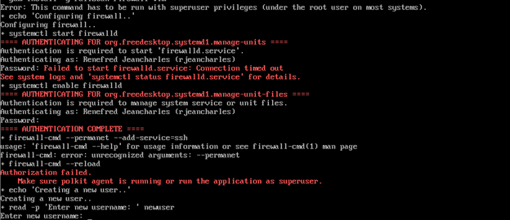

Second script
After several try.
I decided to remove some elements or components from the original script in order to simplify it.
For example, If the ssh configutation part to avoid to compromise the remote access to the server.
I got a simpler script that I had to do some modifications
Screenshort of script
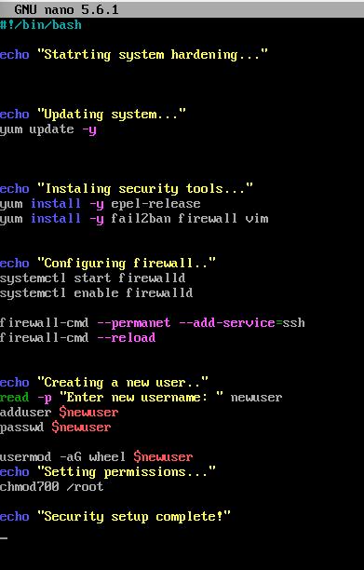

Corrections made by me on this script
firewall AI Mistake ----> firewalld
--permanet -----> --permanent
Chmod700 -----> chmod 700 (space issues)

Screenshort of correct version of Script
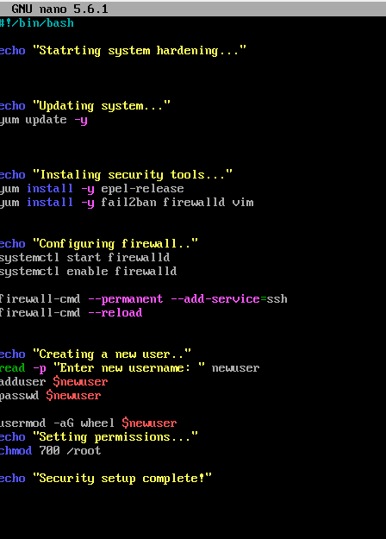
Command use to test if security script is working
sudo bash -x security.sh
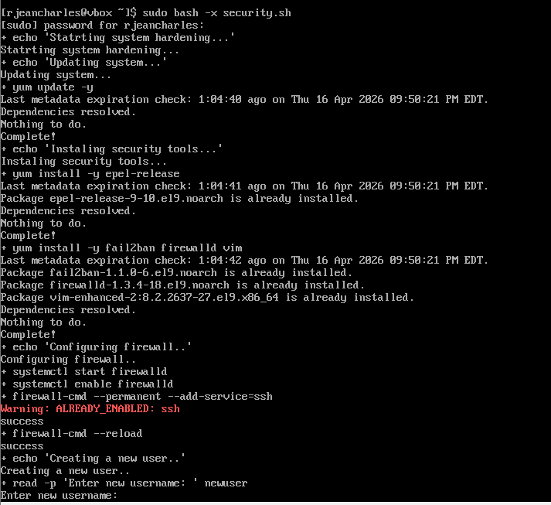

sudo : : Allows to install software that regular users cannot handle
bash : use bash to read file
-x : display every command during the process of verification
security.sh : File name

Adding new user
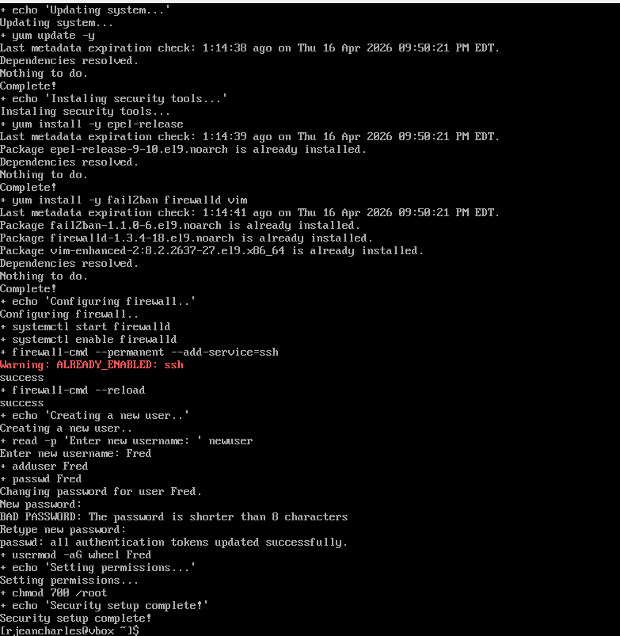

Testing new user
Command use : su-Fred
su : Swithc user
- : Provide the user login environment
Fred: name of new account or user

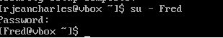

Testing sudo access
Command use : sudo yum update
Sudo: Allows to install software that regular users cannot handle
Yum : allow to update or modify on centOS server
Update: Look for new version of the software

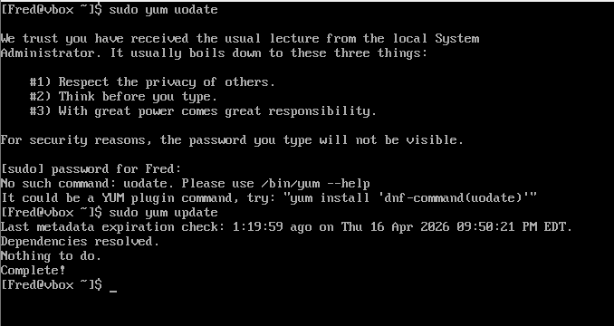

Firewall verification
Command use : sudo firewall-cmd –list all
Sudo : Allows to install software that regular users cannot handle
firewall-cmd: command use to manage Firewalld
–-list all: show all active settings on server

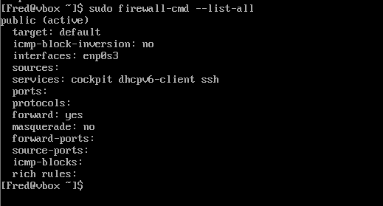

Verify fail2ban
Command use : sudo systemctl status fail2ban
sudo systemctl start fail2ban
sudo systemctl enable fail2ban

sudo : Allows to install software that regular users cannot handle
systemctl: control background services in CentOS server
status: show current state of the service
start : start the service
enable : enable the service
fail2ban: name of service that prevents falselogin attempt

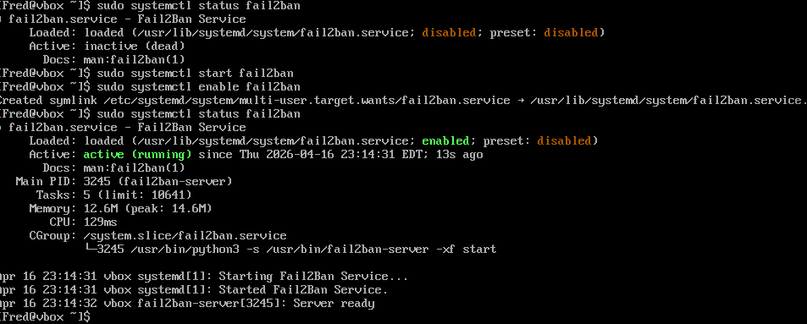

Overall explanation of script
The script starts with yum update -y. It updates the whole system packages to make sure the server is protected in case of vulnerabilities. Important security tools is installed using yum install -y firewall fail2ban, which provides firewall protection and intrusion prevention.
The script starts and enables the firewall using the command systemctl start firewalld and systemctl enable firewalld.. It controls the network traffic and firewall is active after reboot. The command firewall-cmd –add-service=ssh allows access through the firewall. These changes are executed with this command firewall-cmd –reload
The script also starts s and enables fail2ban. The command use is systemctl start fail2ban and systemctl enable fail2ban. It allows the system to monitor login attempts and block suspicious activity.
Chmod 700/root is used to restrict access to sensitive system files to new users.
It also allows the user to add new user or create new account on the system. It is possible because of read-p, adduser and passwd command that are used.

